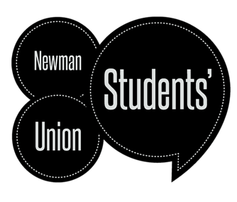

Partnership Grant Application – Part A
2025/26

This form should be completed when two or more societies have identified a project, event, or initiative they wish to deliver collaboratively to encourage wider participation in student-led activities across the Newman community. If you are unsure if your project meets the requirement, please have a discussion with either the Union Director or Vice-President.

Applications should be for no more than £150. Please complete the budget form that accompanies this application in your submission. All completed applications should be submitted to the Vice-President by e-mail at su-vice-president@newman.ac.uk.

The deadline for submission is 5pm 26th March 2026.

Part 1 – Applicant Details

Applicant Name(s)
Partnership Societies
(at least 2)
Proposal Title

Part 2 – Partnership Details

Please provide an outline of your proposed partnership project, event, or initiative below. Include as much detail as possible, ensuring you cover the proposed dates, location (if applicable), and the intended impact on the wider Newman community. (Please expand the box below if you need additional space)

Part 3 - Declaration
By signing this declaration, the undersigned declare that they have consulted members of the partnership societies about the proposed project.

Proposer 1 |  | Proposer 2
Name |  | Name
Signature |  | Signature

Office Use Only
Date Application Received
Date Application Reviewed
Approved/ Rejected/ Amended

